
April 2009 Volume III, No. 2
Among Friends

First printed here in October, 2008, this message is even more important now  Advocacy Action Team  If you believe strongly in the activities and services of the public library consider adding your name to the Advocacy Action Team roster.  As a member of the team you will put your support into action in the form of letters, e-mails, or phone calls as needed to advocate on behalf of the library.  Our biggest need for advocacy usually occurs during the annual  Commonwealth budget process so requests for help won't be frequent, but timing is often critical. It's imperative that we have an updated list of people who can respond to our call to action as need arises.  If you're willing to become a team member or have questions, please call me at 412-422-9650 or e-mail mcculloughh@carnegielibrary.org.  -- Holly McCullough | This old song provides an optimistic picture of the world. In these trying times it is often difficult to believe that springtime, metaphorically speaking, will ever arrive.  Our library, in this time of recession, is receiving less funding from all sides. However, we have more people using the library and all its facilities than ever before in its history. In 2008 Squirrel Hill had 449,239 visitors and thru February 28th of this year we have already had 89,063 (an increase of 20%).  It is important to remember that many people are involved in finding solutions to our funding problems. In the meantime let us continue the good work of the Friends, and don’t forget that springtime always comes.
  PRESIDENT’S MESSAGE  by Joan Schwartzman  “Welcome sweet springtime, we greet thee in song,  Murmurs of gladness fall on the ear.  Voices long hushed now their full notes prolong,  Echoing far and near.” | 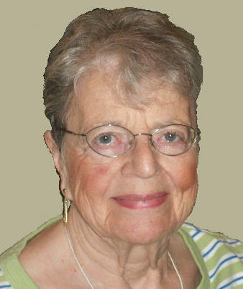
WELCOME, NEW MEMBERS    Come to our monthly  Friends Meetings:  Saturday, April 4 at 10:00 a.m.  Saturday, May 2 at 10:00 a.m. Sunday, June 28 at 2:00 p.m.  (See “Annual Meeting” on page 2)  EVERYONE IS WELCOME | Do you have a PIN yet?  A PIN (Personal Identification Number) is a 4 digit number like those used to add security to ATM cards. The library has recently begun requiring PINs to use the My Account feature on the website, www.carnegielibrary.org; if you don’t have a PIN yet you will be helped to create one the next time you log on to your account. In the future PINs may be needed to use the self-checks and to log on to a computer at the library. In addition, two new services are being offered (see page 5) which will require a PIN to protect your privacy. If you need help setting up your PIN, a staff member at an “Ask a Librarian” desk or the customer service desk will be glad to assist you.  Because the PIN is used to help keep your information confidential, once you’ve set it up only the computer and you know what it is. If you forget your PIN we can reset it to a temporary number so you can go online and change it to one we won’t know, but we can’t tell you what your PIN was because on our end it just looks like gibberish.  If you’d like more information about PINs give us a call or stop in and we’ll be happy to help.
  Linda Bauman  Sandi Behrens  Barbara Burstin  Phyllis Dreyfuss | Rhoda Eligator Gillian Meieran  Beth Sensue  Robert Shapiro
Published by the Friends of the Squirrel Hill Library 5801 Forbes Avenue Pittsburgh, PA 15217
website: www.clpgh.org/locations/squirrelhill e-mail: Friends@pittsburghusedbooks.com
editing: Joan Schwartzman production: Margie Spenser, Marion Damick,
mailing list: Margie Spenser Leigh Anne Vrabel, Serena Spenser
I have always imagined that Paradise will be a kind of library
Jorge Luis Borges 1899-1986
circulation: 288 members, 35 complimentary copies
April 2009 Among Friends Volume III, No. 2

Her first mystery for adults, Frame Work, was published in 2008. Squirrel Hill doesn’t have it yet, but you can request a copy online or at our Customer Service Desk and it will be sent from another branch.  into a struggle for their lives. Along the way, the reader learns about the billions of dollars  worth of art stolen from the Jews and others who died in the Nazi concentration camps.  Ms. Faigen’s second adult mystery, titled Out of Turns and set in Taiwan, will be released by  Avalon Books in December, 2OO9.  If you always do what interests you, at least one person will be pleased.  Katharine Hepburn 1907-2003  ANNUAL MEETING  The annual meeting of the Friends of the Squirrel Hill Library will be held on June 28th at 2:00 PM. The Friends will give an accounting of our activities during the past year, as required by our by-laws, and new officers will be installed. There will be a fantastic program of entertainment, and a social time with refreshments. We hope you will all save the date. | Coming up are:  April: Melissa Underwood  Fraktur Art  May: Milestone Group  Mixed Media  June: Cornelius Tomblin  Abstracts & Surrealism  Our schedule for artists is full through May, 2010! If you are interested in exhibiting after that, contact  Marion Damick,  412-521-3075.  *******************************  New Art from the Old World  The German peoples that migrated to Pennsylvania brought with them a style of folk art, fraktur, which had its roots in the illuminated manuscripts of Europe. Fraktur, which flourished between 1750 and 1850, adorned religious documents and songbooks as well as birth records, and served as rewards from teacher to student. Fraktur consisted of simple or elaborate texts, decorated with naive images including angels, birds, and tulips.  In the Pennsylvania German tradition, I incorporate authentic images from Fraktur pieces of antiquity, adding Fraktur text, translated into English, to recreate a style and share a message from the Old World. My goal is to portray the craftsmanship, charm and simplicity of Fraktur and to pay homage to the Fraktur artists.  --Melissa Von Underwood
  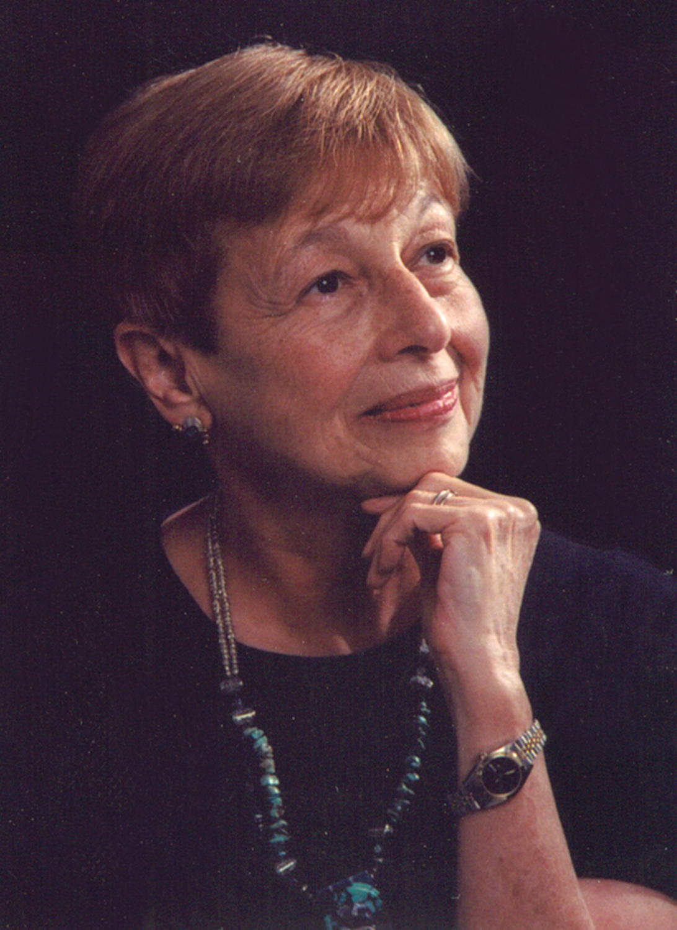 | You Can Borrow Local Author’s Books  From the Squirrel Hill Library  In 1997, Anne G. Faigen wrote her first book for young people, Finding Her Way. Brave Salamander followed in 2005, and New World Waiting in 2006. All three may be found in the Children’s room at the Squirrel Hill library.
  Books for Young People  job out of college was in Pittsburgh, before she  won fame as a writer. | Faigen and her husband, both native Pittsburghers, raised four children in Penn Hills but have lived in Squirrel Hill for 32 years; her son David still lives in the area with his wife and 3 children.  Faigen, who has undergraduate and graduate degrees from the University of Pittsburgh, taught honors and Advanced Placement English at Penn Hills High School and initiated an Advanced Placement English program at Hillel Academy. She has written book reviews for The Pittsburgh Press and Jewish Chronicle and op-ed columns for the Post-Gazette, and is a frequent speaker and book reviewer for civic and women’s organizations, as well as a book group facilitator at Temple Sinai and Hadassah. For more than thirty years she has been a volunteer book reader at the Radio Information Service. She recently recorded her young people’s novels for the Library for the Blind.
    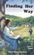 | Finding Her Way, set in pre-Civil War Concord, tells the story of a teenage artist mentored by Henry David Thoreau and Margaret Fuller.
    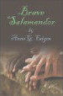 | Brave Salamander, for middle school readers, involves cousins Sally and Amanda -- so close their brothers teasingly call them Salamander -- who help two runaway children in the Underground Railroad.
    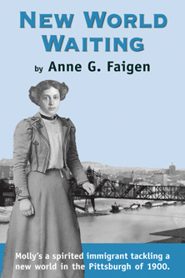 | New World Waiting is set in the Hill District during the 19th century surge of immigrants to our city. Three teenagers of different ethnic backgrounds are best friends and all students of Willa Cather, whose first
  Although it is set in the present, Faigen’s first adult mystery has much in common with the historical novels she has written for children, as it shows how the past still reaches into our lives. An American college professor brings her grandmother along to a literary conference in Prague, where they visit an antique shop and buy an ornately framed print. When they return to their hotel and examine the art work more closely, they find more than they’d bargained for. Their impulsive purchase plunges them into a world of international thieves, Nazi war criminals, and a secret that turns their holiday | 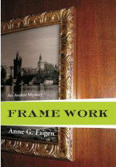
  Art  at the  Squirrel  Hill  Library | 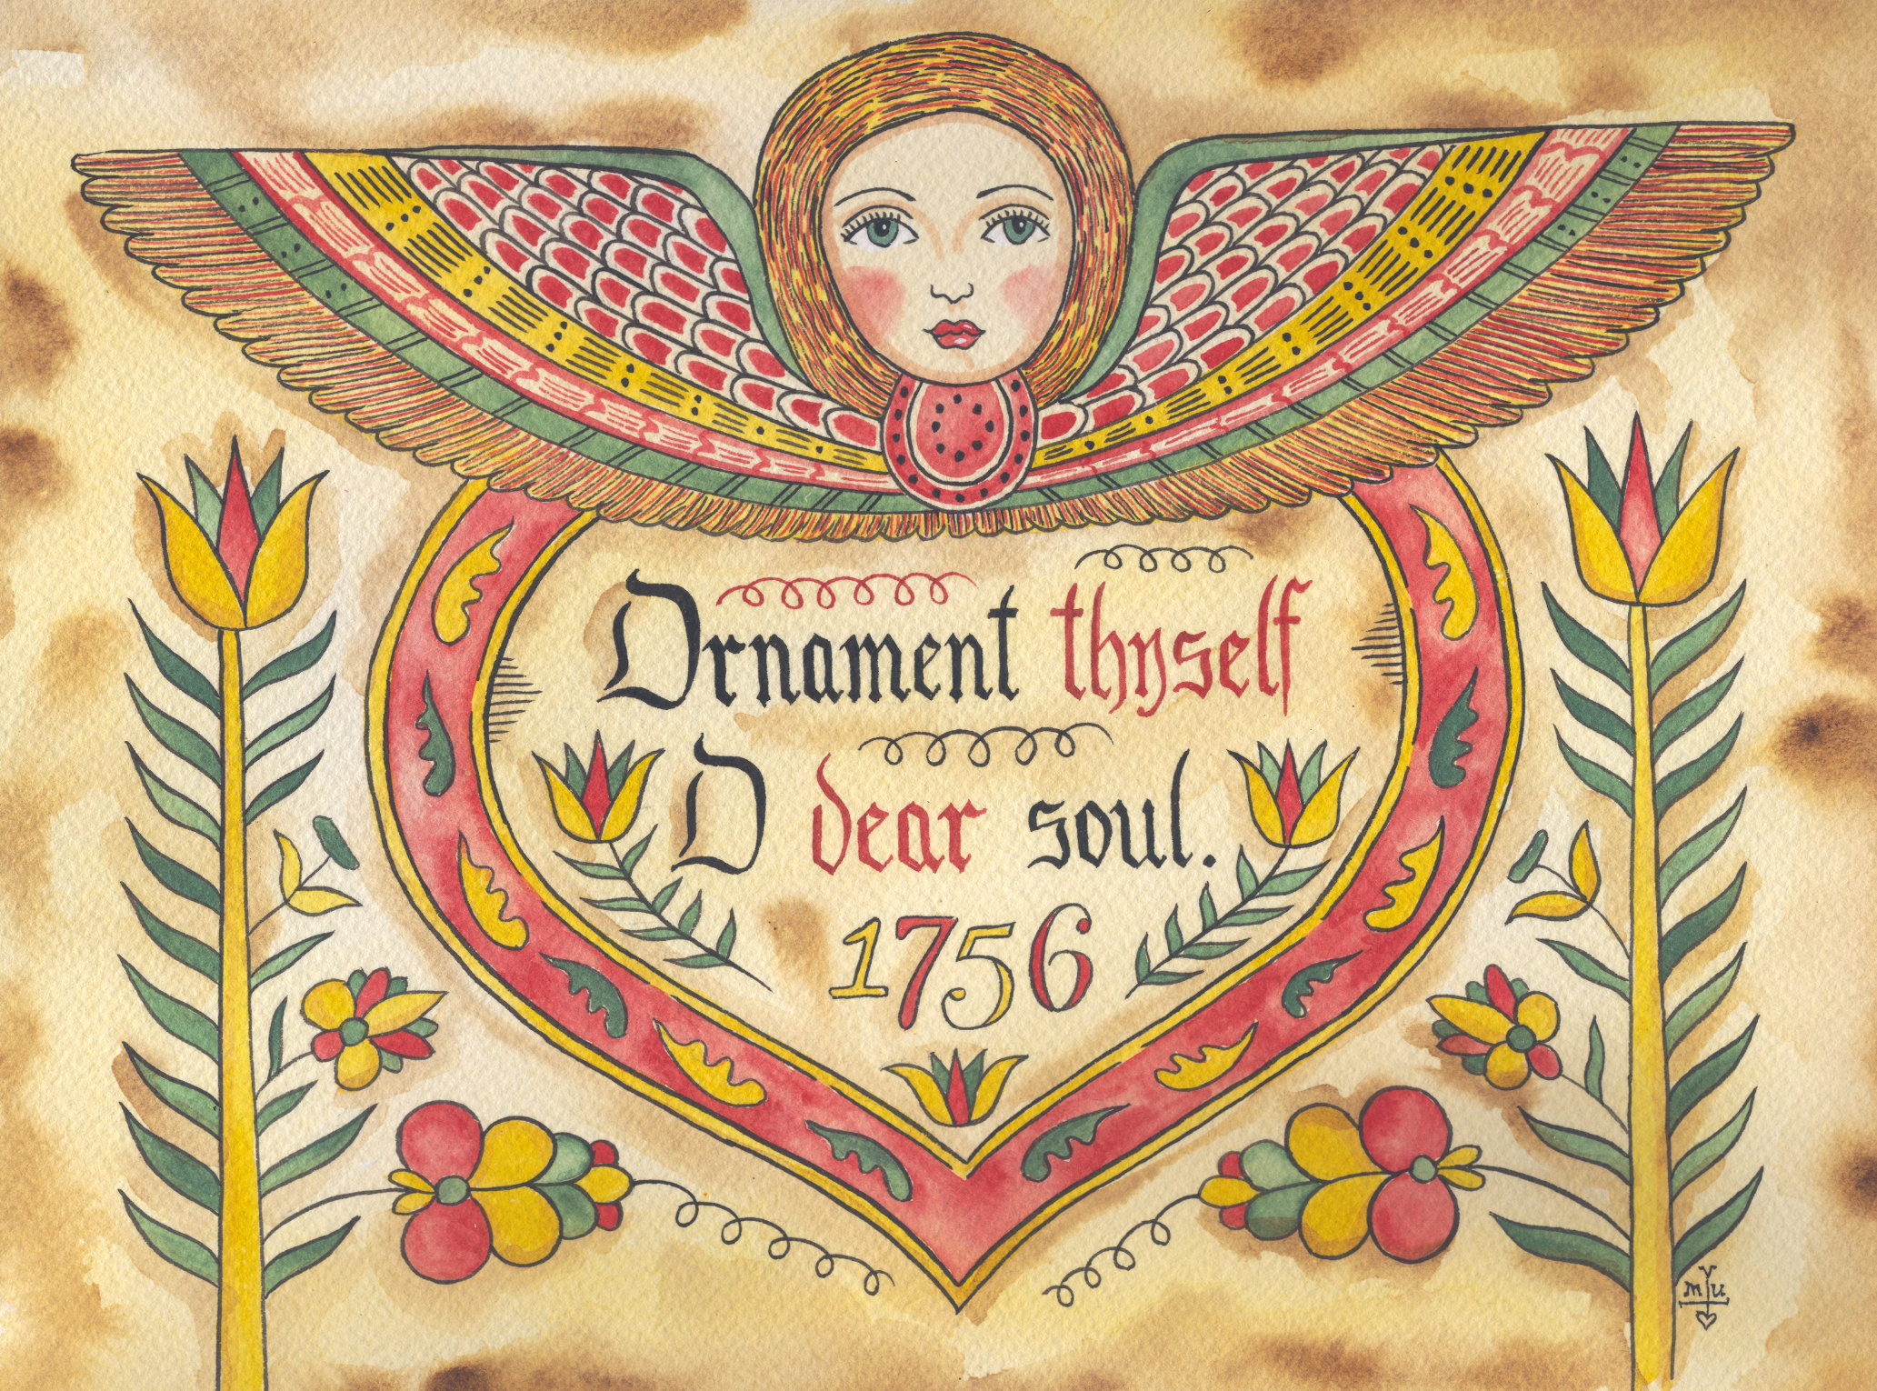
2
April 2009 Among Friends Volume III, No. 2

January. Total earnings were $650 which included $120 from the boutique.  February on the other hand was a sign of the times with earnings of $450. This had a positive outcome, however, because we had a good number of books we were able to donate to the Martin Luther King Reading Room. One of our members, Marilyn Honigsberg,  facilitated this blessing.  You may have noticed our absence in March. A little respite was in order so I took advantage and got a flu instead. Hah! I hope to have a vacation at the shore in April, so while there will be a  mega sale, there will be no mini.
  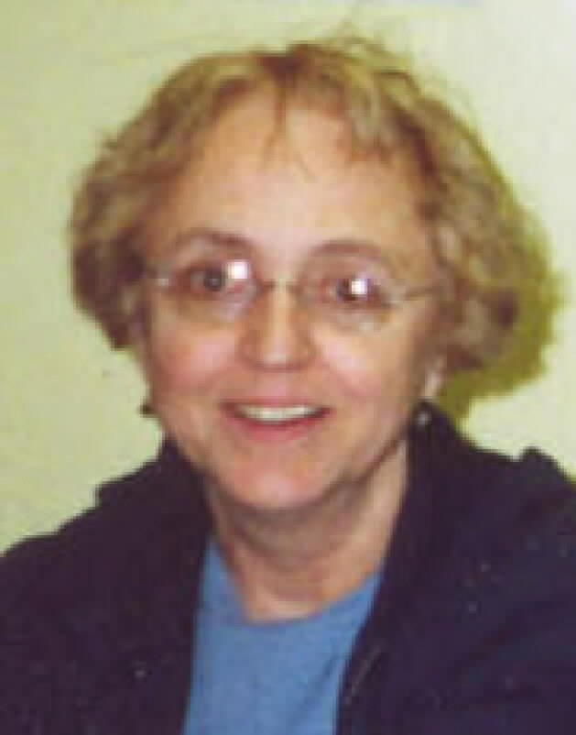 | MINI SALE NEWS  by Pat Bender,  mini-sale chair  Mini sales continued in the New Year with a respectable showing in
  BOOKS, BOOKS, BOOKS, BOOKS, BOOKS, BOOKS, BOOKS, BOOKS, BOOKS  by Margie Spenser  In the January newsletter, I asked for help in finding  (1) the owner of a book we didn’t think was meant to | 
  be donated and (2) a book that we didn’t mean to sell. I wasn’t sure anybody would even read the tiny notices on the bottom of the page, but I should have had more faith. Check out the results below.
  We’re getting ready for our new and improved Spring Cleanup Sale, which is moving from National Library Week to April 24th thru the 27th. Like our October sale, it will take place in the large meeting room near the Marlborough Street ramp and will offer our entire stock of used books, tapes, and disks. We are going to have a particularly large lot of books for toddlers, kids, and teens.
  Monday will be Buy One, Get One Free day.
  Among Friends is going online! One week after the mailed copies are sent out, we will put the newsletter on my website in both Microsoft WORD and Adobe Acrobat’s PDF formats. You can choose the one you need and print it, or just read it online. I will also be putting all the old ones on the website by May 1st. Go to www.pittsburghusedbooks.com and click on the “Friends” button.
  Wouldn’t it be great if all the Bonusgate millionaires split their ill-gotten gains between the food banks and the libraries? While we’re waiting for that to happen, don’t forget that cash donations to the library or to the Friends are tax deductible and badly needed!
  We just got a donation of 20 large cartons of children’s books, and we expect to receive a like number from “Used Books, Rocks, and Crafts” in Indianola, who are clearing out their old store as part of going to online sales only. Our April sale is going to have a fantastic array of books for children of all ages. Don’t miss it!
We will be back on track on May 15, 16 and 17 with Home Arts and Hobbies, Cookbooks, Sports and Fitness, and
Geography and Travel.
Wooly scarves will be gone from the boutique in favor of summer scarves and belts, and baby hats. We are continuing our celebration of Recycled Arts with several new items made with
repurposed materials.
Books to the ceiling,
Books to the sky,
My pile of books is a mile high.
How I love them! How I need them!
I’ll have a long beard by the time I read them. Arnold Lobel
them.  Arnold Lobel | Along with the children’s books, we received many boxes of audio books for adults and VHS tapes for children. At January’s mini sale, we sold several  used VCR’s as “movie players”. We have a few left for April’s sale. We could use more. If you have a VCR you no longer use that will play and rewind, we’ll find it a good home. It doesn’t need to have a working remote or tuner.

Last November,  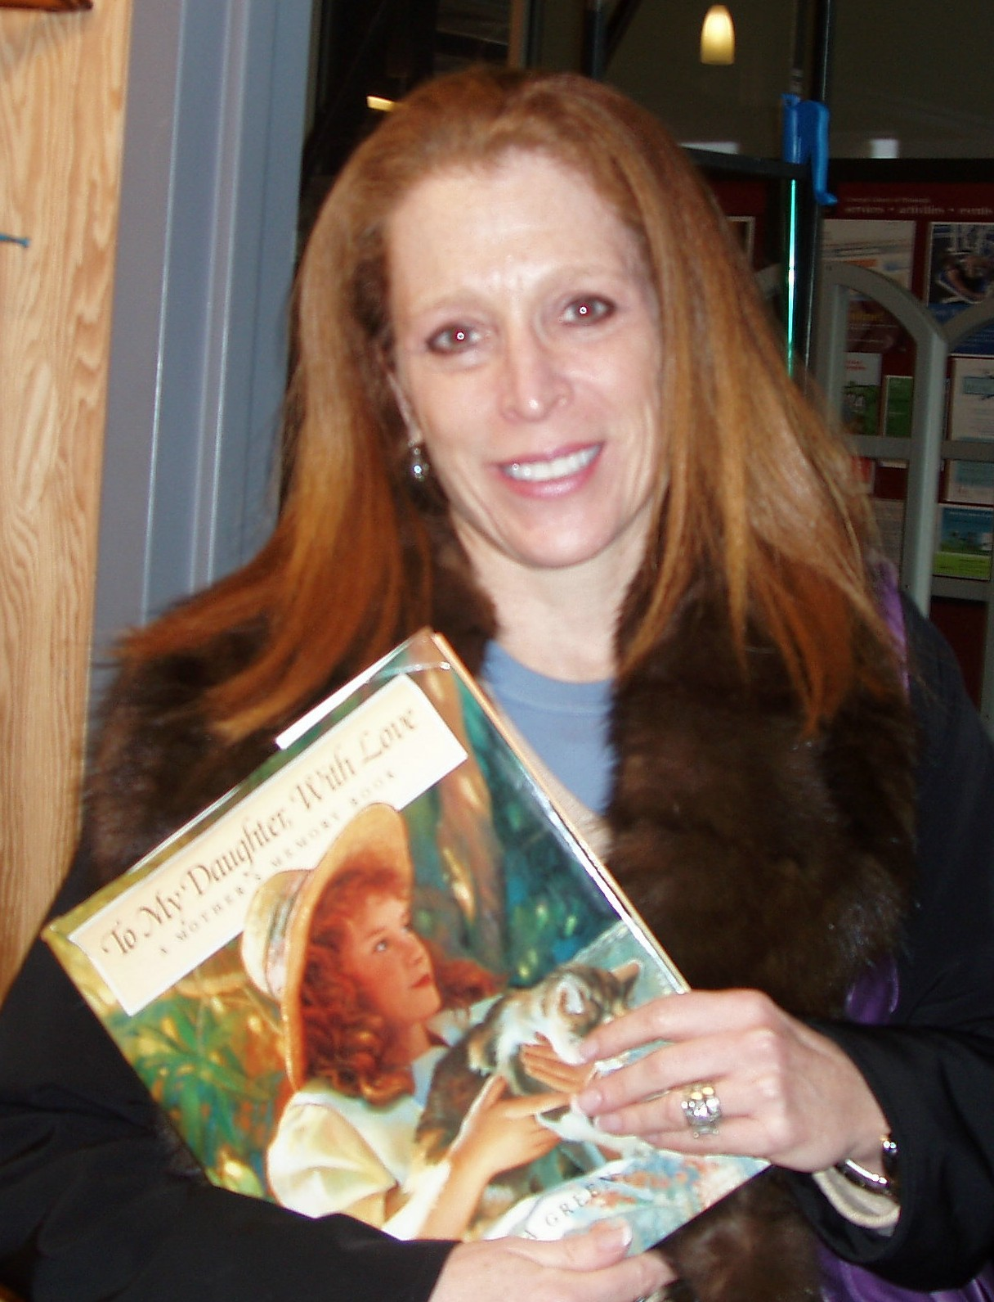  Emily L Goldberg | sorting books, we found a beautiful “baby book” for grownups called To My Daughter With Love. It contained many lovely illustrations interspersed with places to write about family members and add photos. Unlike the usual baby book, this one had been completely filled out by a loving mother. As my daughter said to me, “There’s no way somebody donated this on purpose, Mom. You have to find her.” Following clues in the book, I tried several things but none worked. So I included a plea in my January column: “Does anybody know how to contact Emily Landerman Goldberg? We received a donation that included a book we doubt she meant to give away. I’d like to ask her.” On New Year’s Eve, Lynne Jacobson e-mailed me a phone number, to prove, she said, that “Some People Read Their Newsletter” . I called, and on Friday, January 2 (her mother’s Yahrzeit!) Emily came to the Friends’ workroom to pick up the precious book. She said that she didn’t know how it got donated, because she would never have let it go; it had her mother’s handwriting in it. . . . When told that the book had found its way home, Lynne wrote, “What a great story. I’m so glad it had a happy ending. I knew Emily’s mother -- a great lady! Glad I could be of help.” So am I.
As for my second plea, asking to buy back my library book that was accidentally sold, I didn’t hear from anybody. But when I went to pay for the lost book, I found out that some angel had quietly returned it. Thank you, Somebody!
3

April 2009 Among Friends Volume III, No. 2

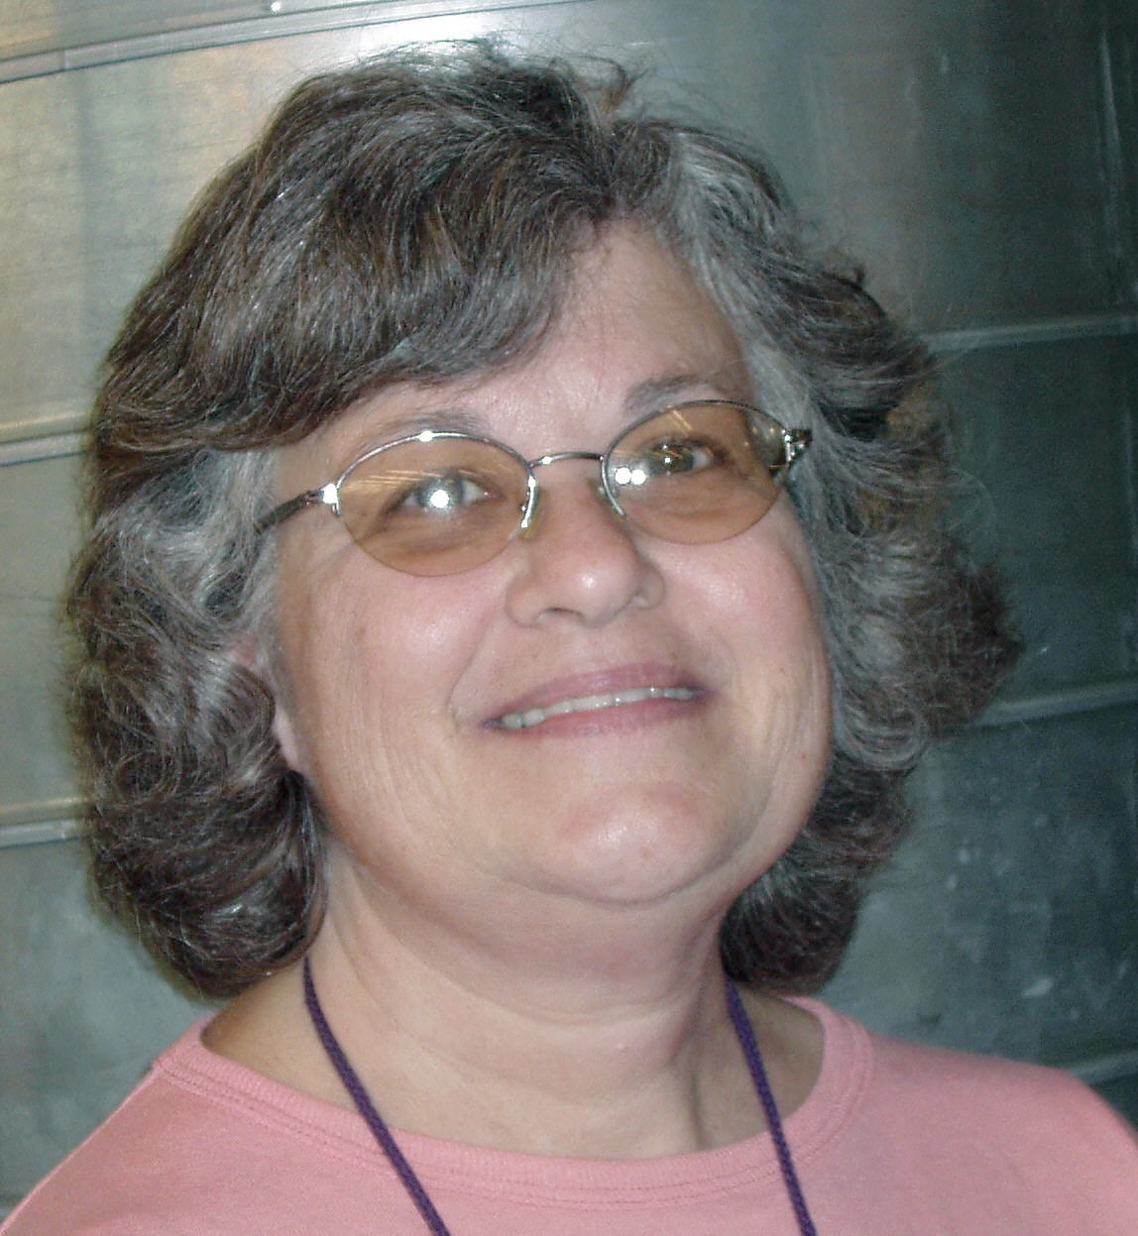
Susan Hughes,  Librarian  Sr. Children’s | Children’s Department Happenings  SPRING onto the internet and explore our new children’s section of Carnegie Library of Pittsburgh’s website, at www.carnegielibrary.org/kids. Listen and watch  books online, play games, get homework help, and even create your own story!  Celebrate the warmer weather with a trip to the Children’s Room  at the Carnegie Library of Pittsburgh-Squirrel Hill!  Special Programs:

One Book, Every Young Child Celebration: In April all of Pennsylvania will be reading If You Were a Penguin by Wendell and Florence Minor to support awareness of early literacy experiences for children. Our library will be participating by having a Penguin Fest on April 11th at 11:00 AM and April 13th at 6:00 PM. Join us for books, songs, crafts and more!

Summer Reading Club: Be Creative @ Your Library is the theme of the Children’s Summer Reading program. Sign up at the 9th Annual Summer Reading Extravaganza (see page 7), or online at www.carnegielibrary.org, or in person at your library. Participation is easy; read at your own pace. Keep track of time spent reading and report it to Librarians or record it online. When you reach 5 hours, choose a free book. Keep reading for a special prize and to get your name on the wall. The Friends of the Squirrel Hill Library will give a local charity an amount of money based on the hours of reading and number of books read by all participants: children, teens, and adults. (For details of Teen and Adult SRCs, check our website, above.)

2009 Children’s Book Awards

- The Newbery Medal goes to Neil Gaiman for The Graveyard Book.
- The Caldecott Medal goes to Susan Marie Swanson, illustrator of The House in the Night by Beth Krommes.
- The Sibert Medal for nonfiction goes to Kadir Nelson for We Are The Ship: The Story of Negro League Baseball.
- The Geisel Medal for easy readers goes to Mo Willems for Are You Ready to Play Outside?
- The Coretta Scott King Award for Illustration goes to Floyd Cooper for The Blacker the Berry.
- The Coretta Scott King Author Award goes to Kadir Nelson for We Are The Ship: The Story of Negro League Baseball.

To read more about these titles and awards visit the American Library Association’s website at http://www.ala.org/ala/mgrps/divs/alsc/awardsgrants/bookmedia/index.cfm.

The 2009 Sydney Taylor Book Awards, given by The Association of Jewish Libraries, were also announced recently:
- As Good As Anybody: Martin Luther King, Jr. and Abraham Joshua Heschel’s Amazing March Toward Freedom by Richard Michelson with illustrations by Raul Colon (for younger readers),

- Brooklyn Bridge by Karen Hesse (for older readers).

Read more at http://www.jewishlibraries.org/ajlweb/awards/st_books.htm.

Stop by or call the library to reserve a copy of these great award-winning books!

New Non-fiction
T is for Tugboat: Navigating the Seas from A to Z by Shoshanna Kirk. Sail through the
alphabet from Anchor to Zephyr.
All about Sleep from A to Zzzz by Elaine Scott. Find out what’s happening while you’re
lying in bed.
Barack by Jonah Winter. An inspirational look at President Obama’s journey to the White House.

New Fiction
Penina Levine is a Potato Pancake by Rebecca O’Connell. Penina’s adventures continue in this second book by a Pittsburgh-based author.
Swindle by Gordon Korman. Sixth grader Griffin Bing puts together a band of misfits to steal back a baseball card.
Hate That Cat by Sharon Creech. This sequel to Love That Dog tells of the daily life of Jack through poems.

New Picture Books
When Louis Armstrong Taught Me to Scat by M.H. Weinstein. Explore the world of jazz through this fun tribute to Louis Armstrong.
Naked Mole Rat Gets Dressed by Mo Willems. Naked mole rats don’t wear clothes, until Wilbur convinces them that wearing clothes can be fun in this hilarious new book by the author of Don’t Let the Pigeon Drive the Bus.
Welcome to the Zoo by A. Jay. Have fun going on a treasure hunt as you go for a walk through the zoo.
There is no frigate like a book,
To take us lands away.
Emily Dickinson
4 More on page 7

April 2009 Among Friends Volume III, No. 1

Programs are scheduled for Wednesday from 10:15 AM-11:00 AM  unless otherwise marked  Franchising  Can’t find a job? Franchising may be an alternative option.  Discover business opportunities in today’s economy.  John Tubridy, Franchising Consultant, frannet.com  Wednesday, April 29 @ 10:15 AM.  Speak with power, presence, and poise:  how to use the art of confidence and influence to get results!  Maureen Murray, www.maureenmurrayassociates.com  Wednesday, May 13, 2009 @ *1:00 PM (special time)  Out of a job? Learn about health care benefits and options.  It's an increasingly common story these days - you lose your job,  and your health insurance goes with it. Now what?  Stephen Rzonca,Pennsylvania Department of Insurance  Wednesday, May 20, 2009 @ 10:15 AM  Find a job fast in a tough economy.  If you are changing jobs or careers, whether voluntarily  or involuntarily, you know it can be especially challenging  during a recession.  Attend this program to learn exactly how to get hired, fast.  Chris Posti, President, Posti & Associates, Inc.  Tribune-Review Careers Columnist,  Income tax returns are the most imaginative fiction being written today.  Herman Wouk 1915-  Executive Coach and Outplacement Counselor  Wednesday, May 27 at 10:15. | The library has added two new features to the online catalog in the My Account section. The first feature, Reading History, can help you keep track of what you’ve already read. Use this list to jog your memory, to remind yourself of books you loved (or hated!) or titles you want to recommend to friends. There is no way of getting a list of items that you’ve checked out in the past, but if you start now you’ll have a nice list built up in no time.  The other new feature, the Wish List, allows you to create lists of items you find in the catalog that you may be interested in for future use. I’ve already used this feature to list items that I’ve seen in book reviews and want to read when I have time.  Reading History and the Wish List are entirely voluntary and confidential. To activate either one you must enter your library barcode number and your new PIN at www.carnegielibrary.org and My Account. (For more info about PINs see page 1.) To ensure privacy and confidentiality, neither of these new features can be accessed by staff; only you can activate/deactivate them or use them.  My Account also lets you see what items you have out currently, renew items, see fines and fees, save preferred searches and view and place holds. Because of the power of this feature, it has been changed recently to require a PIN for these old activities too.  As always, if you have questions please call and ask a librarian at 412-422-9650.
   | NAMM BUSINESS CENTER PROGRAMS  April - June 2009  by Dorothy Kabakeris,  Namm Librarian | 
  Library Offers Exciting New Features  for Borrowers | 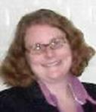
Get the Free Monthly Namm Business Center Newsletter!
Sign up to receive a monthly e-mail that highlights the business programs held at the Squirrel Hill library. A special feature is the list of new business books added to the Namm Collection, but available to anyone in Allegheny County on request. The titles cover a wide range of interests, including: starting and financing a business, attracting good employees, increasing one's own productivity, and investing money and time wisely. To subscribe, e-mail squirrelhill@carnegielibrary.org.

Meet Some Important People: watch for more in the next issue
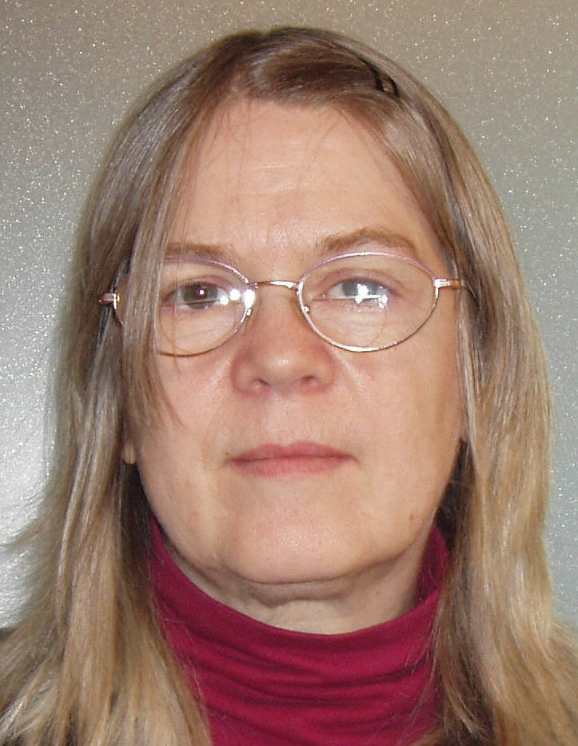  Katherine Hackney  Children’s Librarian |   Kayla Sargeson  Page | 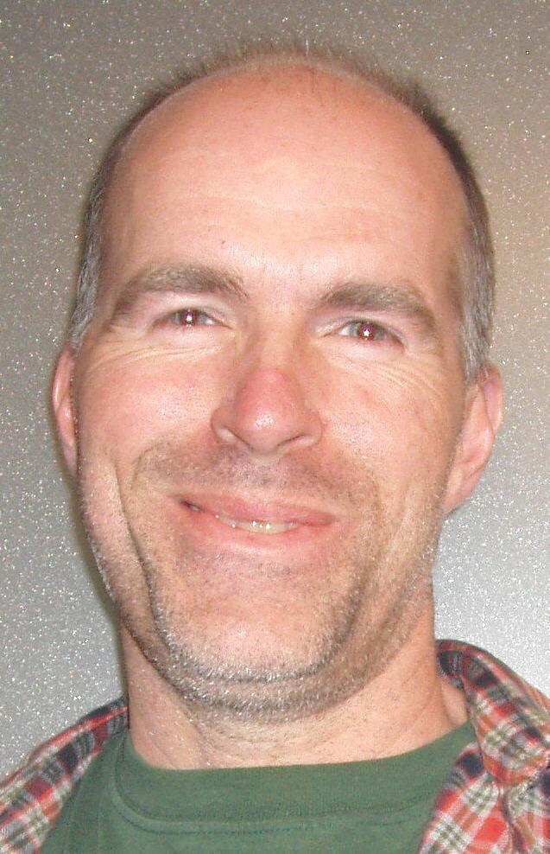  Mark Kirby  Librarian | 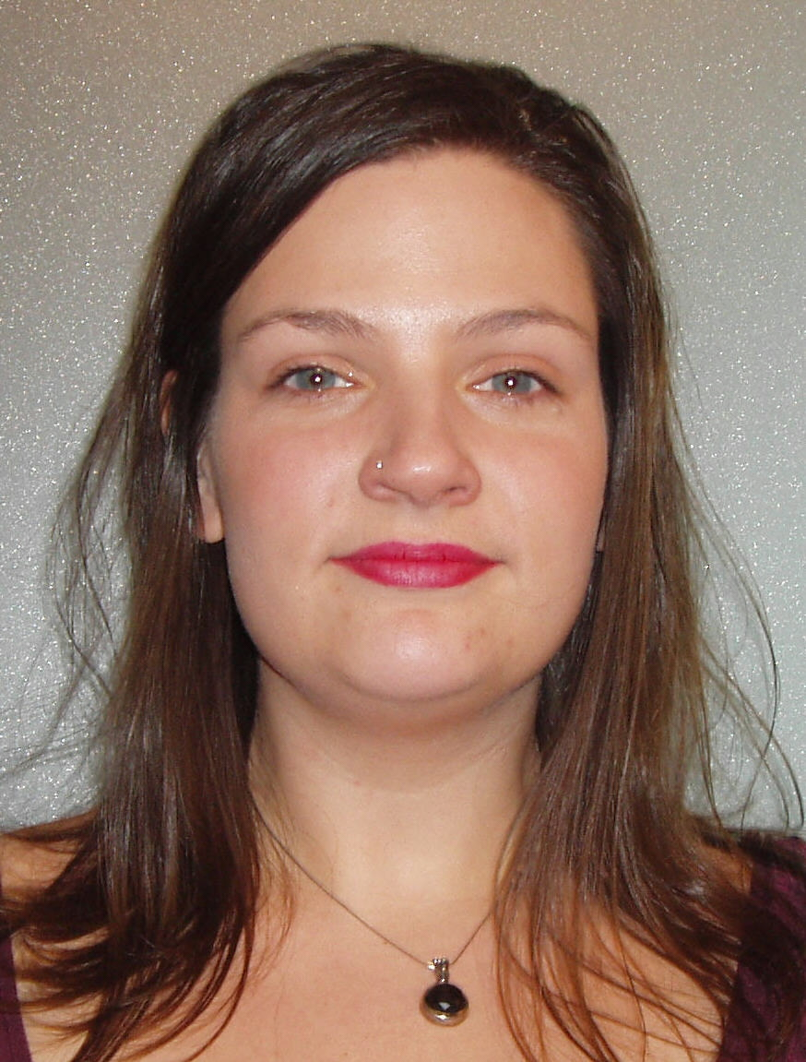  Jayme Kostandinu  Children’s Clerk | 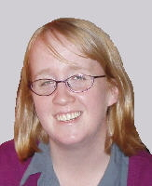  Abby Alexander  Clerk
5

April 2009 Among Friends Volume III, No. 2

Film, Fiction, and Fun is a special series presented at the Carnegie Library of Pittsburgh, Squirrel Hill on the third Thursday of each month from 1 to 4 p.m. It explores the relationship between films and the novels that inspired them. Attendees are encouraged to read a monthly fiction selection, then join CCAC’s Jeanne Bergad for a screening of the film and discussion to follow.  April 16th’s title is Othello, by William Shakespeare. One of Shakespeare’s most famous tragedies, Othello follows the story of the title character, a Moorish general in the Venetian army, as his life is systematically destroyed by Iago, a jealous subordinate. The great Laurence Olivier donned blackface to play the title role in a 1964 staging of the play by the National Theatre of Great Britain. This performance was filmed in 1965, and Olivier’s Othello remains the only Shakespeare film in which all four principal actors (Olivier, Maggie Smith, Frank Finlay, and Joyce Redman) were nominated for Oscars.  May 21st’s book is The English Patient, by Michael Ondaatje. Set at the end of World War II in an abandoned Italian convent, the story centers on Hana, a Canadian nurse who refuses to abandon her final charge, a burn victim known only as the “English Patient.” The two are eventually joined by a crippled thief and an Indian sapper, and the tale of the mysterious patient is gradually revealed. The 1997 film based on this novel was directed by Anthony Mingella, who took four years to complete the screenplay. Mingella’s attention to detail was rewarded with 9 Oscars, including an award for the director and a best supporting actress award for Juliet Binoche in the role of Hana.  June 18th’s title is The Haunting of Hill House, by Shirley Jackson. Published in 1959, this classic ghost story follows the efforts of Dr. John Montague to find and document supernatural activity within Hill House, an old mansion with a history of violent death. Stephen King has named this book as one of the best horror novels of the 20th century, and one can see its influence in King’s own novel, The Shining. Jackson’s story was brought to film in 1963, simply entitled The Haunting. The movie was directed by Robert Wise, and it starred Julie Harris, Claire Bloom, and Richard Johnson.  All good books have one thing in common. They are truer than if they had really happened. Ernest Hemingway 1899 – 1961  3 |   The Squirrel Hill  Adult Book Discussion Group  meets on the fourth Thursday  of the month.  All are welcome.  April 29 @ 1:00 PM  Swimming to Antarctica: Tales  of a Long-Distance Swimmer  by Lynne Cox, 2004  May 28, 2009 @ 1:00 PM  The Commoner  by John Burnham Schwartz, 2008 (a novel)  June 25, 2009 @ 1:00 PM  The Wild Trees : A Story of  Passion and Daring  by Richard Preston, 2007.
   | Film,  Fiction,  Fun  by Mark Russell, Librarian  | 
  Film, Fiction, Fun  moderator  Jeanne  Bergad | 
  April 16
  Othello
  by William Shakespeare
  May 21
  The English Patient
  by Michael Ondaatje
  June 18
  The Haunting of Hill House
  by Shirley Jackson
  filmed as The Haunting
One Book One Community 2009 The Giver, by Lois Lowry

The Allegheny County Library Association has recently announced that this year’s selection for the 7th annual One Book One Community program is The Giver, by Lois Lowry. As in past years, ACLA encourages readers of all ages to read the book, talk about it with friends and neighbors, and attend One Book One Community programs at libraries all across the county.

The Giver takes place in a utopian future. A number of society’s problems have been eliminated, such as poverty, unemployment, and injustice. However, as one boy discovers, this seemingly perfect way of life comes with a price.

For more information about The Giver and the One Book One Community program, you can call ACLA at 412-921-1123 or visit www.onebookonecommunity.org. For Lois Lowry accepting the Newbery: www.loislowry.com/pdf/Newbery_Award.pdf. A discussion of Lowery, The Giver, and subsequent books: http://www.post-gazette.com/ae/20040218lowry0218fnp3.asp.

6
April 2009 Among Friends Volume III, No. 2
USED BOOK  SALE  Home Arts/Hobbies  Travel & Cookbooks  Relax and Enjoy the Sunshine  Fri May 15th noon to 4:30 p.m.  Sat May 16th 10 a.m. to 4:30 p.m.  Sun May 17th 1 p.m. to 4:30 p.m. | Summer Reading Extravaganza!  9th Annual  Free Family Festival  Sunday, June 7, 2009  12:00 PM - 5:00 PM  Be Creative @ Your Library!  Carnegie Library of Pittsburgh – Main  in Oakland will have children, teens and adults singing and dancing as the excitement builds to summer reading. Bring your family and join us for a fun-filled afternoon of games, crafts, story telling and food. Don’t forget to bring your library card!  Featured prominantly will be a  USED BOOK TENT  COME SIGN UP FOR SUMMER READING  FOR CHILDREN, TEENS, OR ADULTS   Before you critize someone you should walk a mile in their shoes. That way, when you criticize them you’re a mile away and you have their shoes. Jack Handey 1949 –
  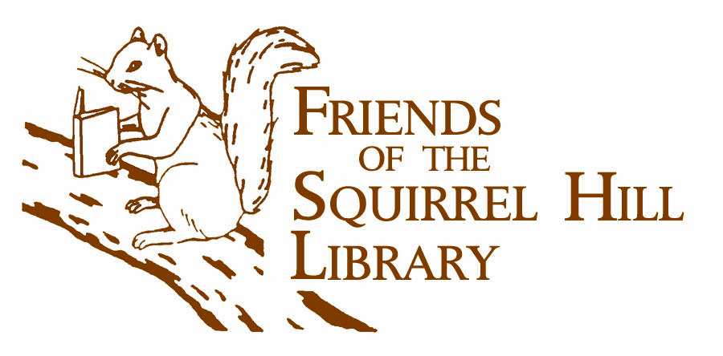
  Children’s Monthly Programs:
  KinderPrep: The 2nd Tuesday of the month at 6:00 PM; April 14 and May 12. A literacy-based program designed to reinforce skills for children entering Kindergarten in fall 2009. Please register by calling 412 422-9841.
  Origami: On the 3rd Saturday of the Month, April 18th, May 16th, and June 20th, The Origami Club of Pittsburgh holds classes: the beginner class is at 12:00 PM and the advanced class is at 1:30 PM. Come join the fold!
  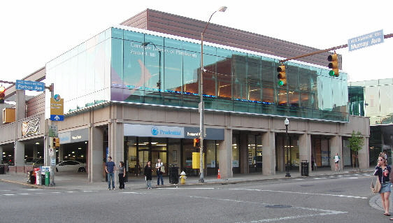
  Squirrel Hill Library
  5800 Forbes Ave.
  412-422-9650800 Forbes 41212-422-9650
  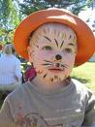 | Location:  Main Library Lawn  4400 Forbes Ave  Pittsburgh, PA 15213 | 

The Friends of the Squirrel Hill Library
5801 Forbes Avenue
Pittsburgh, PA 15217

Library Hours:
Monday, Tuesday, Wednesday – 10 to 7
Thursday, Friday, Saturday – 10 to 5
Sunday – 1 to 5

“Free to the People”
Children’s Weekly Programs:

Family Storytime
Mondays at 6:00 PM
Saturdays at 11:00 AM

Toddler Storytime
Tuesdays at 10:30 and 11:30 AM

Baby Lapsit
Thursdays at 10:30 and11:30 AM
Meet YA Author Libba Bray!

Behind the Book:
Authors Talk to Teens

Thursday, April 16
7:00 PM - 9:00 PM

Meet the author of Victorian fantasies A Great and Terrible Beauty, Rebel Angels and The Sweet Far Thing. Selected titles will be given away while supplies last.
sponsor: PPG Glass

7

7

April 2009 Among Friends Volume III, No. 2

Make checks payable to:  Friends of the Squirrel Hill Library  and mail to:  Margie Spenser  5900 Douglas St  Pittsburgh, PA 15217  Check one box:  New Member Renewal  Check one OR two boxes:  $5.00 $10.00 $15.00  $25.00 Other____ DONOR (free)  Name:___________________________________  ^{(Last)} ^{(First)}  Address: _________________________________  City/State: __________________Zip: __________  Phone(s): ___________________Date: _________  E-mail address: ____________________________  Please check all activities you can help with:  Periodic Book Sales Sorting Used Books  Adopt-a-Shelf Program Gardening  Library Advocacy Newsletter/ Mailings  (lobbying, writing letters)  COMMENTS_________________________  _________________________________  _________________________________ | SPRING CLEANUP  USED BOOK SALE every book in stock,  including a great many  PICTURE BOOKS  AND EASY READERS  (for 1st -3rd graders)  Friday April 24 10 a.m. to 4:30 p.m. Saturday April 25 10 a.m. to 4:30 p.m. Sunday April 26 1 p.m. to 4:30 p.m.  Monday April 27 10 a.m. to 4:30 p.m. *  * ½ price day  DONATIONS WELCOME
  5801 Forbes Avenue
  412-422-9650
The man who does not read
good books
has no advantage over
the man who can’t read them.
Mark Twain (1835-1910)
line3
CARNEGIE LIBRARY OF PITTSBURGH  SQUIRREL HILL  5801 Forbes Avenue 15217 |  |  | NON-PROFIT ORG.  U.S. POSTAGE  PAID  Pittsburgh, PA  PERMIT No. 307
Adult Services: 412-422-9650  Children's Services: 412-422-9841  Fax: 412-422-5811  www.carnegielibrary.org/clp/sq  Is your Friends Membership up to date? Please check your mailing label/membership card ➔.  If the date is before 04/09, you need to renew. If you bring this page to one of our Used Book Sales, you'll get a free book with your renewal. Or mail us the form above.  your donation is tax deductible  as a charitable contribution | ADDRESS SERVICE REQUESTED  8 | FIRST  CLASS
  
  EXPIRES:  January 2010 | Sylvia Sussna  1538 S. Negley Ave  Pittsburgh, PA 15217-1420

